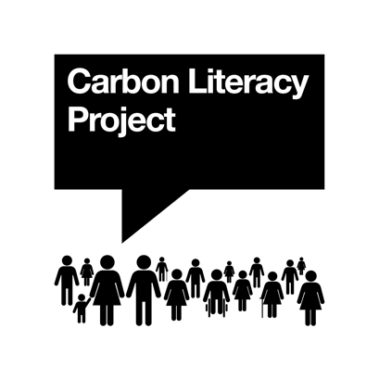
Carbon Literacy Content Consent Form

Sharing your experience with Carbon Literacy helps to inspire other people and organisations to take part in Carbon Literacy training and pledge actions to reduce their emissions, thereby amplifying Carbon Literacy.

By completing this form, you give us permission to use and retain your content, including words/quotes/text and/or media, for use in our communications. You can choose to opt out at any time by emailing media@carbonliteracy.com.

Full name
Email address
Name of your organisation
Job title/Role in your organisation
Connection to Carbon Literacy
Name of organisation delivering Carbon Literacy (if applicable)

I give permission for The Carbon Literacy Project to use and retain my content for use in: Please tick or highlight as appropriate
 | Text | Media
Training materials: Carbon Literacy training courses and Toolkit materials e.g., case studies of excellent pledged actions
Social media: The Carbon Literacy Project’s social media platforms (e.g., LinkedIn, Twitter, Instagram, Facebook, Vimeo)
Website and email marketing: The Carbon Literacy Project’s website (including blogs), Carbon Literacy newsletters
Press and traditional marketing: Press releases, news articles, or any other marketing materials

Please state any other preferences below: e.g. I would like my name/organisation/role to remain anonymous

I understand that the information I submit here will only be used in connection with The Carbon Literacy Project. It will only be used for the purposes submitted above. My information will never be sold or transmitted to a third party beyond the need to process it, and will only be used in connection with Carbon Literacy.

I am happy to give my permission:

Signature: __________________________________________
(Signature of parent, guardian or teacher,
if participant is under 18 years of age)

Date: __________________________________________

