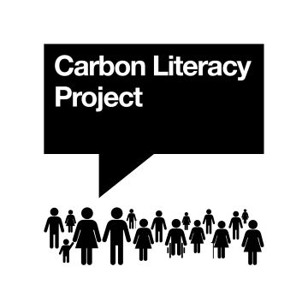
Carbon Literacy - Certification Request Form
CLAD 2025

Please complete and submit this form for each participant for whom you would like a Carbon Literacy
Certificate as evidence of their Carbon Literacy training. When completed please email it, together with a
completed Participant & Evidence Form for each learner, and details of payment to: evidence@carbonliteracy.com

Training delivered: / / Evidence submitted: / /

Training organisation:
The organisation that will appear on the certificate will be that of the training organisation unless we are otherwise advised. If the learners’ organisation should be used instead, please tick here. For individuals that differ from the group, please let us know in the notes section below.

Responsible trainer:

Responsible trainer has gained the following
certifications/experiences (tick all that apply): Carbon Literate (individual) Attended DSCL* CLF CLT CLC
*DSCL (Delivering Successful Carbon Literacy) – free online workshop run monthly by the CLP for trainers, usually attended once before training delivery.

Course ID number: CC Course name:

Audience/initiative (please select no more than 2): Workplace Education Community
If this is your first submission of evidence to The Carbon Literacy Project, for your first delivery of CL or under this course ID number, please tick here.

We like to tell people about organisations like yours getting people certified as Carbon Literate. If you are happy for us to publicise the certification of this batch of learners on social media, please tick here.

Certificate payment is being provided via: Please complete and/or tick as appropriate.

Cheque (attached Y/N) |  | Bank Transfer |  | Purchase Order: |  | PO No: | Pre-purchased

Budget / Initiative (if applicable): CLAD 2025

Notes: Please provide additional information about the group or individual learners if it is required.

Participants:
Please PRINT all words clearly. Please note that the organisation and participant names will appear on
the certificate exactly as stated here.

* If our CLK e-learning was used to deliver CL, please state the date your learners’ completed their CLK e-learning.
Contact The Project if you’re not sure how to find this information.
Please don’t complete this column if it was a different e-learning module that was used, rather than our CLK e-learning module.

No. | First name(s) | Last name | Participant email address | Organisation (if different from Training Organisation) | *E-Learning Completion Date | Evidence Attached?
1
2
3
4
5
6
7
8
9
10
11
12
13
14
15
Continuation Sheet:

No. | First name(s) | Last name | Participant email address | Organisation (if different from Training Organisation) | *E-Learning Completion Date | Evidence Attached?
16
17
18
19
20
21
22
23
24
25
26
27
28
29
30

We do not recommend training groups of more than 30 individuals at a time, to ensure enough time for feedback and review during action planning.

