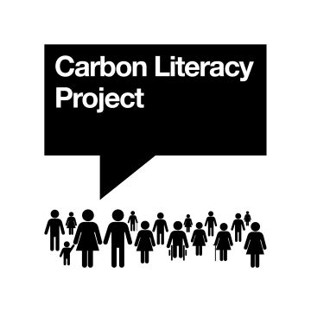
Carbon Literacy - Certification Request Form
Please complete and submit this form for each participant for whom you would like a Carbon Literacy Certificate as evidence of their Carbon Literacy training. When completed please email it, together with a completed Participant & Evidence Form for each learner, and details of payment to: evidence@carbonliteracy.com

Training Session:

Final Training Date (DD/MM/YYYY): Submission Date (DD/MM/YYYY):

Training Organisation:

CC
Course ID Number: Course Name: This is my first delivery of CL under this course ID
In-Person Delivery |  | Online/Distance Delivery |  | Mixed Delivery
The Course ID Number is a 6-digit number, preceded by “CC”. If you are not sure of your Course ID Number, please let us know before submitting.
Delivery Setting (not including e-learning):
Please mark one Delivery Setting in relation to live/real-time training. For Delivery Setting definitions, please see our Course Creation and Definition Guidance Document.
Workplace |  | Education |  | Community
Audience/initiative (please select no more than 2):

Delivery Nation: Delivery Language:

Trainer(s):
Lead Trainer(s) has gained the following accreditations/experiences* (mark all that apply):
(Full name)
CL |  | DSCL |  | CLF |  | CLT |  | CLC
CL |  | DSCL |  | CLF |  | CLT |  | CLC
Lead Trainer 1:
(Full name)
Lead Trainer 2:

Other trainers:
* CL = Carbon Literate (Individual), DSCL = Has attended a Delivering Successful Carbon Literacy workshop, CLF = CL Facilitator, CLT = CL Trainer, CLC = CL Consultant

Training Org |  | Learner Org(s) |  | Other:
Certificates:
Organisation (to appear on certificate):

Budget Name/Code (if applicable):
Pre-purchased |  | Pay-as-you-go |  | PO No (if applicable):
Method of Payment:
Notes: Please provide additional information about the group or individual learners if it is required.
Additional Permissions:
We like to tell people about cohorts like yours becoming Carbon Literate.
If you are happy for us to publicise the certification of this batch of learners on social media, please tick here.

Participants:
Please include the names of all learners who attended the training session, even if they have not yet completed their evidence form. We do not recommend training groups of more than 30 individuals at a time, to ensure enough time for feedback and review during action planning. Please add rows as necessary.
* Please state the date on which each learner completed their CL-managed e-learning (including CLK). Contact The Project if you’re not sure how to find this information. Please do not complete this column if you have used e-learning which was not accredited by The Carbon Literacy Project.
No. | First name(s) | Last name | Participant email address | Organisation (if different from Training Organisation) | * E-Learning Completion Date | Evidence Attached?
1
2
3
4
5
6
7
8
9
10

No. | First name(s) | Last name | Participant email address | Organisation (if different from Training Organisation) | *E-Learning Completion Date | Evidence Attached?
11
12
13
14
15
16
17
18
19
20
21
22
23
24
25
26
27
28
29
30

