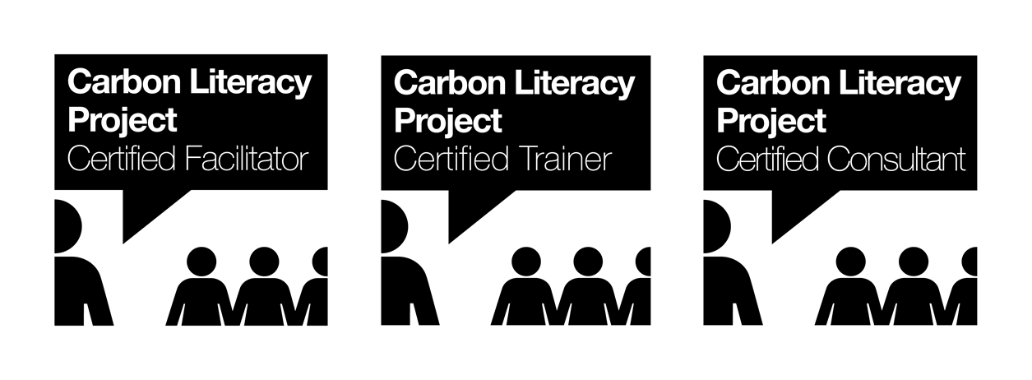

The Carbon Literacy Project:

Trainer Standard

Version 5.0

“Carbon Literacy® is an awareness of the carbon costs and impacts of everyday activities, and the ability and motivation to reduce emissions, on an individual, community and organisational basis.”
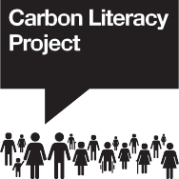

Acknowledgements

The Carbon Literacy Trust would like to gratefully acknowledge the people and organisations who have contributed their time, knowledge, and goodwill to influence and improve this Standard, supporting The Carbon Literacy Project.

We would particularly like to thank:

The founding members of The Carbon Literacy Working Group;

The current and former trustees of The Carbon Literacy Trust

But especially our Project Volunteers, past and present;

We gratefully acknowledge the founding support of:


Manchester City Council

and
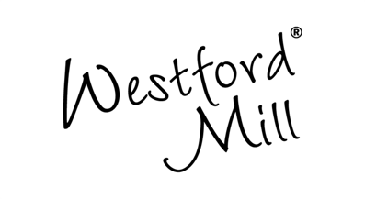
Founding Sponsor of The Carbon Literacy Project: Westford Mill,
www.westfordmill.com

The Carbon Literacy Project is owned for the public benefit by: The Carbon Literacy Trust Registered Charity Number 1156722

Contents
Acknowledgements 2
Introduction 4
Trainer Pathway graphic 5
Trainer Certification Scheme Tiers 6
Qualifying as a Certified Trainer 7
Carbon Literacy Facilitator (CLF) Requirements 8-9
Carbon Literacy Trainer (CLT) Requirements 10-12
Carbon Literacy Consultant (CLC) Requirements 13-16
Applying for the Trainer Certification Scheme 17
Pricing Matrix 18
Renewals 19
Carbon Literacy Certification and Accreditation Schemes 20-21
FAQs 22
Enquiries 23

Introduction:

Overview of the Trainer Certification Scheme

Peer-to-peer delivery is an integral part of Carbon Literacy (CL). This means that training can be delivered by non-professional trainers as long as they belong to the peer groups of the learners. This is exactly as intended. However, the Project understands the benefits to an organisation of having the support of professional trainers or consultants in developing and customising their own CL training and/or delivering it. The Project recognises that there is a need to identify and distinguish the most experienced and capable trainers, and to enable them to evidence their experience and ability.
As a result, the Carbon Literacy Trainer Certification Scheme has been developed, introducing three distinct tiers of trainer certification:
- Carbon Literacy Facilitator (CLF) (Level 1)
- Carbon Literacy Trainer (CLT) (Level 2)
- Carbon Literacy Consultant (CLC) (Level 3)

As a guarantee of professional standards, trainers at levels of certification are required to comply with the Carbon Literacy Project Trainer Code of Conduct.

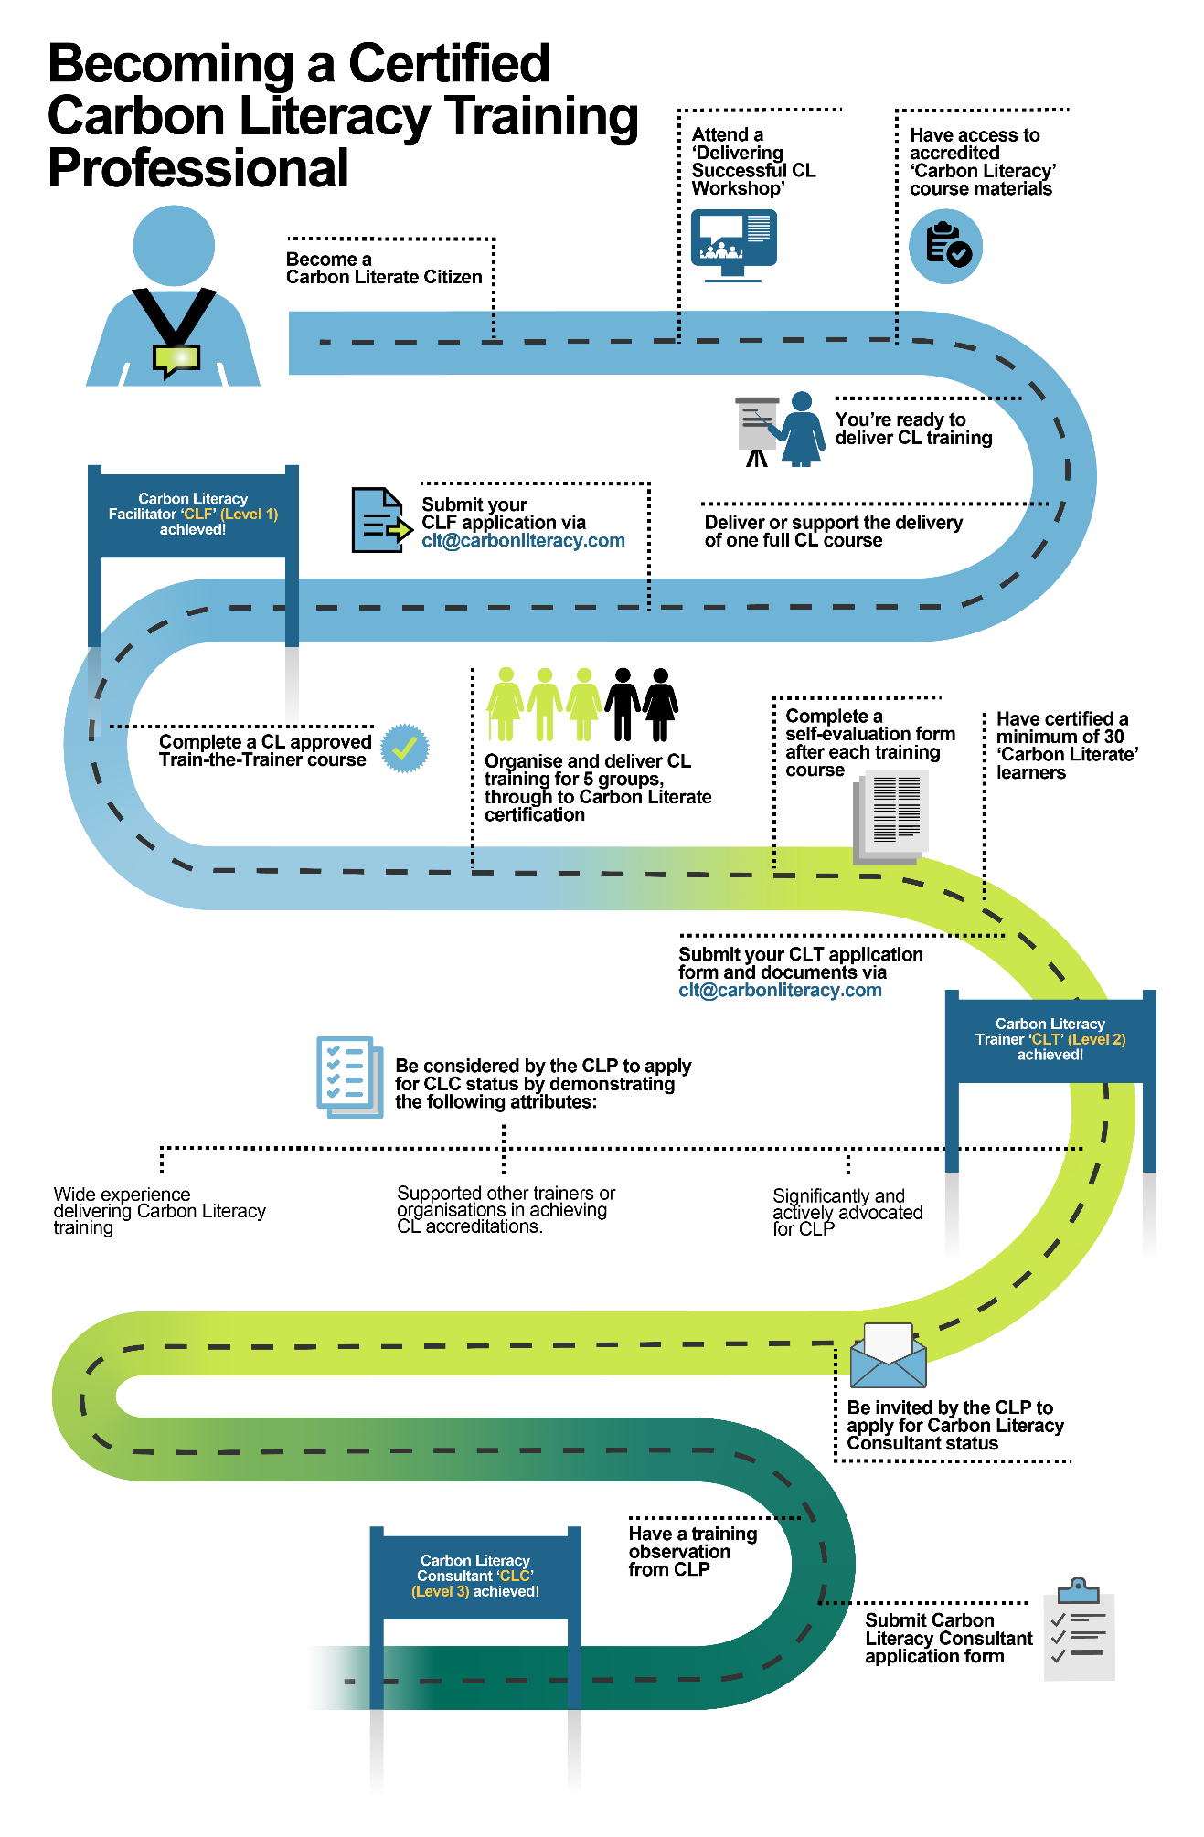

Trainer Certification Scheme Tiers

The three tiers of the Trainer Certification Scheme reflect increasing levels of expertise in
CL course organisation, communication, design, and delivery. The requirements for each level are summarised below, and mapped out in detail in the pages that follow.

Level 1: Carbon Literacy Facilitator (CLF)
The first step on the trainer certification ladder. CLF certification demonstrates a basic understanding of the Carbon Literacy Standard, training group organisation, communication of the messages surrounding the training, classroom facilitation and basic Carbon Literacy training skills. The Project certifies this level without charge, and we expect all trainers to apply for the CLF award after their first training delivery.

Level 2: Carbon Literacy Trainer (CLT)
This certification builds upon Facilitator experience and requires an increased level of CL delivery experience. Certified CLTs will have delivered Carbon Literacy training to multiple groups of learners and been responsible for the successful submission of learners’ evidence forms. CLT is designed to accredit those who can evidence the development of their trainer skills by attending a CL-accredited Train the Trainer course, or, with the agreement of the Trainer Network Team, through a non-CL CPD or other approved route.

Level 3: Carbon Literacy Consultant (CLC)
A Carbon Literacy Consultant is currently the highest rank of individual qualification. CLC certification highlights and awards individuals that have both depth and breadth of experience in Carbon Literacy training design and delivery to a wide range of organisations. It is likely to include; successful certification of individuals, experience in training individuals to become Carbon Literacy Facilitators and Trainers (CLF and CLT), and/or supporting organisations to achieve accreditations (CLO and CLE). Candidates will undergo direct external observation from the CLP and assessment of training delivery, to directly validate the evidence in their portfolio.

We hope that applicants will be both challenged and excited by the prospect of gaining these higher-level Carbon Literacy qualifications and will enjoy and benefit directly – not just through the process of developing their skills and gaining the qualification, but also from the volume, variety and quality of work and experience that being a certified Trainer, or Consultant generates.

Qualifying as a Certified Trainer:

Carbon Literacy Facilitator (CLF) Carbon Literacy Trainer (CLT) Carbon Literacy Consultant (CLC)

Overview

To qualify as a CLF, CLT or CLC, several assessment criteria must be met at each level to demonstrate increasing levels of expertise within the field of training delivery. Certifications will be awarded on the strength of the evidence provided on the application form and in supporting documents. Certifications must be achieved in order, starting with Level 1, CLF.

The criteria for each level are explained in detail in the pages that follow. The links to download the application documents for each certification can be found on page 16 of this document, and the costs of certification in our Pricing Matrix.

Applicants will find it helpful to gather evidence of their CL training delivery as they go and keep these on file, e.g., dates of delivery, learner names, successful evidence submissions data, examples of communication strategies, preparatory notes from their training sessions, feedback from their learners, etc. The Project may ask for additional evidence and information regarding any application, and some applications will be randomly selected for more detailed enquiry as part of internal quality assurance processes. The more collateral evidence of the work delivered by the applicant, the better. The higher the level of certification, the more evidence will be required, as explained in detail below.

Further queries? Please address them to: clt@carbonliteracy.com

Requirements for Level 1

Carbon Literacy Facilitator (CLF) Certification

A CLF will have overseen and/or supported the delivery of Carbon Literacy within their setting.

A CLF will:

Requirement: | Evidenced by: | Notes:
1. Be a Carbon Literate Citizen. | The applicant must have attended a Carbon Literacy course and achieved a Carbon Literacy certification.  Will supply the unique certificate number found on their Carbon Literacy certificate on the CLF application form. | Applicants who are not yet Carbon Literate but wish to apply for CLF can find open CL courses to attend here- Open CL course booking page  Contact the Project- info@carbonliteracy.com if you’re struggling to find a place on an appropriate course.
2. Have attended a Delivering Successful CL Workshop (DSCL). | The applicant must have attended and participated in a DSCL Workshop run by the Project. This course familiarises the applicant with the Carbon Literacy Standard and ensures confidence in facilitation through the discussion of key processes.  The applicant will supply the date of their DSCL attendance on the CLF application form. | Book onto a Delivering Successful CL Workshop via our events page  If you are struggling to find workshop availability, contact the Trainer Network Team- clt@carbonliteracy.com
3. Have completed the Trainer Survey | The applicant must complete the Trainer Survey as indicated on the CLF application form. | Completion of this survey ensures our databases are up to date and helps the Trainer Network Team to understand and support the needs of CL trainers.
4. Have delivered or supported the delivery of one full (day’s worth) CL course  OR  Managed the administration,  evidence gathering and certification process for a minimum of one cohort, through to successful Carbon Literacy certification. | The applicant must provide an account of their role in delivering, supporting or managing the evidence process for one full CL course, including;  Details of their involvement in:  - Course delivery.  - Organisation of a training course.  - Learner evidence gathering  - Administration and submission of the evidence forms, to successful certification.  - How they felt about delivering/supporting or managing the certification of the CL course.  - Any learning for future delivery.  The strength of this narrative account will determine whether the applicant can be certified or not. | The applicant must have delivered and/or assisted with the delivery of one full CL course.  Names of learners within the cohort/s must be provided to allow the Project to check that learners have successfully achieved Carbon Literacy certification.

The Benefits of Becoming a Carbon Literacy Facilitator (CLF)

A certified Carbon Literacy Facilitator will be awarded: -

- A uniquely coded Carbon Literacy Facilitator certificate for display, showcasing the experience gained by the applicant.
- A Carbon Literacy Facilitator logo for use on website, social media, training materials, and other communication.
- Access to the growing informal network of Carbon Literacy trainers

Requirements for Level 2
Carbon Literacy Trainer (CLT) Certification

A CLT is an experienced freelance or organisational CL Trainer who has organised and delivered Carbon Literacy training to multiple groups of learners and developed their skills as a trainer. A CLT will have had more CL delivery experience than a CLF and detailed knowledge of the Carbon Literacy Standard.

Once awarded, CLT certification status is valid for 3 years from the date of award.

A CLT will:

Requirement: | Evidenced by: | Notes:
1. Be a certified  Carbon Literacy Facilitator (CLF). | The applicant must have been certified as a CLF and will be able to supply their unique certificate number on the CLT application Form. | If the applicant has not yet been certified as a CLF, but wishes to apply for CLT, applications can be submitted simultaneously. However, all requirements still need to be met for both certifications.
2. (a) Have completed a CLP-accredited CL Train-the-Trainer course  OR, where agreed with The Project  (b) Be able to evidence training experience and capabilities through non-CL training deliveries and continued professional development. | (a) The applicant must supply course dates, times and details of the Train the Trainer delivery organisation within their CLT application Form.  (b) Where agreed with the Trainer Network Team, the applicant will provide details of their previous training deliveries and professional development activities, such as non-CL training using the CLT Supplementary Evidence Form to evidence their CL-specific knowledge and skills. | (a) A CLP-accredited CL Train-the-Trainer course is designed for professional or organisational trainers undergoing the certification process for CLT. Only accredited courses can be used to obtain CLT certification.  For details of upcoming Train-the-Trainer courses, contact the Trainer Network Team at clt@carbonliteracy.com  Attending a Train-the- Trainer course is the preferred route to certification as it specifically focuses on the delivery of CL.  (b) Applicants following the Supplementary Evidence route must discuss this in advance with the Trainer Network Team –  clt@carbonliteracy.com  Use of the Supplementary Evidence route will be made at the discretion of the Project and will only be granted to the most accomplished trainers.
3.(a) Have successfully organised and delivered CL training and gathered learner evidence for multiple groups of learners, as lead trainer, each cohort having achieved Carbon Literacy certification.  Including:  Delivery to at least 5 cohorts. 1 cohort = 1 group of learners, a majority of whom have reached Carbon Literacy Certification with a minimum of 4 learners per cohort.  AND  Delivery to a minimum of 30 learners who have reached ‘Carbon Literacy’ certification.  3. (b) compiled a Self- Evaluation Portfolio or Case Study. | (a) Cohort information (training dates, course code and names of the learners) must be given so that the Project can review the evidence submitted from a particular cohort if required and check that the learners have received ‘Carbon Literate’ certification.  (b) For three of the first five cohorts, the applicant must complete a Self-Evaluation Form (template provided in the CLT application pack) demonstrating how they have progressed, adapted, developed, and implemented improvements in their training, within and between cohorts. These three reports combine to produce a Self-Evaluation Portfolio to be submitted with the CLT application Form.  If applicants are named as co-lead trainers on the Certificate Request Form then Self-Evaluation Forms must be completed for all five cohorts, evidencing equal responsibilities.  Applicants who have delivered extensively, but whose cohorts have been spread over time or whose first five deliveries happened some time ago, may submit a Case Study instead of self-evaluations (on agreement with Trainer Network). Applicants can find the Case Study Guidance in the CLT application pack.  Please submit EITHER a Self-Evaluation Portfolio or a Case study | The applicant does not need to have designed the training or been responsible for the Criteria Checker but must have collected and submitted the evidence for the learners as far as the organisation’s agreed process allows.  The applicant must be named as the lead trainer on the Certificate Request Form for each cohort being submitted as evidence.  A lead trainer is defined as having taken responsibility for ALL aspects of the training including;  - Organisation of the course.  - Ensuring materials are up to date.  - Course delivery.  - Evidence form gathering, feedback and submission.  If these responsibilities are shared equally between two trainers, they may cite two names on the Certificate Request Form as lead trainer. The strength of evidence given in the CLT application form will determine whether further evidence of training delivery is required.  Please note: The Project will assess the CLT capabilities of the applicant based solely upon the strength of the evidence that is supplied.

The Benefits of Becoming a Carbon Literacy Trainer (CLT)

A Certified Carbon Literacy Trainer will be awarded: -

- A uniquely coded Carbon Literacy Trainer certificate for display, showcasing the skill and experience gained by the applicant.
- A Carbon Literacy Trainer logo for use on website, social media, training materials, and within other communication.
- Inclusion by request on the Carbon Literacy Project’s Trainer Directory on the Carbon Literacy Project website.
- With prior permission, introductions to organisations seeking external trainers.
- Free of charge access to all Carbon Literacy Trainer workshops and networking events.
- Priority marketing support through the Carbon Literacy Project communication channels.
- An invitation to the Carbon Literacy Trainer Celebration in the year of CLT certification.
- CLT certification can contribute directly towards other Carbon Literacy accreditations and certifications. Carbon Literate Training Organisations (CLTO) must have a minimum of 1 CLT or CLC working for the organisation to qualify for and maintain their accreditation. CLT certifications within an organisation can also be used as supporting evidence of Impact or Advocacy towards Carbon Literate Organisation (CLO) and Carbon Literacy Educator (CLE).

Requirements for Level 3
Carbon Literacy Consultant (CLC) Certification

CLC is the highest level of CL Trainer certification and is offered on an invitation-only basis directly by The Carbon Literacy Project. A CLC encompasses both depth and breadth of experience in Carbon Literacy training design and delivery, usually across a range of organisations and settings. A CLC understands the Carbon Literacy Standard intimately and has designed and successfully accredited multiple CL courses for a range of different audiences. A CLC has also demonstrated the skills required to train individuals to become Carbon Literacy Facilitators and Trainers (CLFs and CLTs), and will have supported other trainers and organisations to achieve a range of their own CL accreditations.

An external observation and assessment of the training delivery and communication skill of every CLC applicant is made by the Project. This ensures an exemplary level of quality and expertise is achieved, and the body of certified CLCs remains clearly identifiable as individuals operating at the highest level.

Nominations can only be made by CLP team members, and nominations are thoroughly assessed by the Project's senior leadership team and by trustees of the Carbon Literacy Trust. A Trainer will normally have been certified for three years at the very minimum before being nominated for the first time and it is normal for excellent Trainers to be considered multiple times over an extended period before progressing. Successful nominees will then be personally approached and invited to apply for certification. By design, the Carbon Literacy Consultant certification is reserved only for those operating at the very highest level and will always form a far smaller cohort than the cohort of certified Trainers, to ensure the accreditation denotes the very highest standards.

Once awarded, CLC certification status is valid for 3 years from the date of award.

Requirement: | Evidenced by: | Notes:
1. Be a certified Carbon Literacy Trainer (CLT). | The nominee must have been certified as a Carbon Literacy Trainer and will be able to supply their unique certificate number on the Carbon Literacy Consultant (CLC) Application Form. | In the unlikely event that a nominee has not yet been certified as a CLT, we will first initiate a conversation about how to meet this requirement. before any consideration as a CLC.
2. Have a breadth of experience of delivering Carbon Literacy training. | The applicant must submit a trainer log demonstrating achievement of 50 points worth of CL experience and delivery using the following scoring:  - New CL training course Criteria Checked and delivered as lead trainer = 3 points  - Delivery of an existing CL course within the same context or organisation as lead trainer = 2 points  - Delivery of Sector Toolkit CL course to an organisation as lead trainer = 1 point | The trainer log should include the following information;  - Course delivery dates  - Organisation names within which training delivered, OR audience delivered to for open courses  - CL course names and ID numbers (6-digits beginning CC000___)  - Evidence as to whether courses were prepared for Criteria Checking by the applicant, or someone else  - Total number of learners certified under the direct supervision of the applicant  - Co-leading trainer details (if applicable)
3. Have supported other trainers or organisations in achieving CL certifications or accreditations. | The applicant must provide full details as to how this requirement is met, including; specific trainer or organisation names, dates, and description of what the applicant's role was in supporting them (min 300 words). | These may include the following;  - Providing trainer shadowing or mentoring opportunities  - Supporting the achievement of CLO, CLE, CLT, CLTO & Localities (CLL) accreditations and certifications
4. Have significantly and actively advocated for The Carbon Literacy Project. | Provide full details of how this requirement is met; including specific activities/projects, dates, and a description of what involvement the applicant had. (min 300 words). | These may include;  - Public engagement supporting increased levels of Carbon Literacy, eg speaking engagements, conference and panel contributions, written articles or interviews  - Promotion of Carbon Literacy via social media and other channels  - Regular attendance at CLP Trainer Network engagement events  - Volunteering for speaker spotlights either with CLP or relevant partners  - Sharing best practice with the wider CLP Trainer Network

The Benefits of Becoming a Carbon Literacy Consultant

To reflect the investment and achievement of the highest trainer certification possible, the cohort of CLCs will have: -

- All the benefits of CLF and CLTs.

- A uniquely coded Carbon Literacy Consultant certificate for display, showcasing the top-level skill and experience gained by the applicant.
- One-to-one training observation exercise and coaching style feedback designed to support improved performance and professional development.
- A Carbon Literacy Consultant CLC logo for use on website, social media, training materials, and other communication.
- Priority recommendation (opt-in) to organisations interested in being quoted for CL training and consultancy work.
- Invitation to the Carbon Literacy Trainer Celebration every year.
- Invitation to the Carbon Literate Organisation Awards every year.
- Priority profile individually and on behalf of their clients as part of Carbon Literacy Action day (CLAD).
- Invitation to join a CLC Panel to comment on and help shape Carbon Literacy Project policy, activities, consultation, and collaboration.
- The Carbon Literacy Consultant pin badge, presented at the annual Trainer Celebration.
- CLC certification can contribute directly towards other Carbon Literacy accreditations and certifications. Carbon Literate Training Organisations CLTO must have a minimum of 1 CLT or CLC working for the organisation. CLC certifications within an organisation can also be used as supporting evidence of Impact or Advocacy towards Gold or Platinum Carbon Literate Organisation CLO awards.
Thus CLC accreditation offers very significant added value both to the holder, any organisations they choose to work for, and any client they choose to work with.

Applying for the Trainer Certification Scheme:

When you are ready to apply for the Trainer Certification Scheme, please check that you have filled in the following forms and supporting documents listed for each level;

Carbon Literacy Facilitator CLF

- Carbon Literacy Facilitator (CLF) Application Form

Download the CLF Application form here-

Carbon Literacy Facilitator (CLF) Application Form

Carbon Literacy Trainer CLT
- Carbon Literacy Trainer CLT Application Form
- Self-Evaluation Portfolio (x 3 Trainer Self-Evaluation Forms or x 5 Trainer Self-Evaluation Forms if Co- Co-delivering OR, where agreed, a Case Study)
- Carbon Literacy Trainer CLT Supplementary Evidence (where agreed with the Trainer Network Team in lieu of a Train the Trainer course)

Download CLT application documents here-

Carbon Literacy Trainer (CLT) Application pack

Carbon Literacy Consultant CLC

CLC Application documents are provided to applicants upon successful nomination.

- Carbon Literacy Consultant CLC Application Form
- Carbon Literacy Consultant CLC Trainer Log
- Carbon Literacy Consultant CLC Observation Form - This is the matrix Assessment Tool used by the CLP during the Training Observation to assess ability and delivery as a trainer against a series of headings. Applicants do not complete this but may well wish to view it and be familiar with the criteria before the Training Observation. This form is completed by the CLP external observer during the observation and then reviewed and discussed in a one-to-one coaching session with the applicant.

Please familiarise yourself with all the preceding pages and to save yourself time, please ensure you do meet all the requirements for the relevant accreditation before submitting your application to the Trainer Network Team.

Further queries? Please address them to the Trainer Network Team at: clt@carbonliteracy.com

Pricing Matrix

The Carbon Literacy Project aims to make Carbon Literacy training as accessible as possible to as many people as possible - cost shouldn’t be a barrier to entry. This is reflected in our pricing matrix by making our level 1 Carbon Literacy Facilitator (CLF) accreditation free of charge and without an expiry date.

For those who wish to have the professional recognition and benefits of the higher certification levels of Carbon Literacy Trainer (CLT) and Carbon Literacy Consultant (CLC) there are costs associated with both the initial certification and the renewal.

You can find the current price for CLT and CLC certifications in our Pricing Matrix

Trainers at any level of certification are expected to act in accordance with our Trainer Code of Conduct. The Carbon Literacy Trust reserves the right to withhold or withdraw any certification at any level, at any time.

Renewals

Renewals are required for both CLT and CLC accreditations. This helps the Project maintain quality, keep track of accredited trainers and consultants, and ensure resources are being directed to support the most active trainers in the network. Applicants who decide not to renew their CLC or CLT status will still retain their CLF status.

Carbon Literacy Facilitator (CLF)
Certification does not expire and may be used indefinitely.

Carbon Literacy Trainer (CLT)

Renewal is required every 3 years from the date of issue. Applicants must complete a Carbon Literacy Carbon Literacy Trainer (CLT) Renewal Form and submit a Case Study.

Carbon Literacy Trainer (CLT) Renewal Form

Carbon Literacy Consultant (CLC)

Renewal is required every 3 years from the date of issue. Applicants must get in touch with the Trainer Network Team to renew their certification.
https://carbonliteracy.sharepoint.com/:w:/s/CarbonLiteracyProject/EQrNF3KzLs9MoTxH_LIltBgBUsTEUWYyNGydW54GpCxvOQ?e=K4gxJj

Carbon Literacy Certification and Accreditation Schemes:

One of the key aspects of The Carbon Literacy Project has always been that involvement would enable any successful participant to receive a certificate to evidence their Carbon Literacy. The Carbon Literacy Trust (registered charity number: 1156722 ) was established to own and safeguard the assets of The Carbon Literacy Project, and oversee the dissemination of Carbon Literacy nationally and globally.

The full list of certification and accreditation schemes offered by The Carbon Literacy Project includes:

Carbon Literacy (CL) certificate
Successful participation in a Carbon Literacy initiative by an individual will result in the awarding of a Carbon Literacy (CL) certificate. Each certificate is uniquely numbered, and participant details are held on a secure database by the Trust to allow for later verification by the participant and their employers or other external bodies.

Carbon Literacy Facilitator (CLF)
The first step on the trainer certification ladder. CLF certification demonstrates a basic understanding of the Carbon Literacy Standard, training group organisation, communication of the messages surrounding the training, classroom facilitation and basic Carbon Literacy training skills.

Carbon Literacy Trainer (CLT)
This certification requires an increased level of CL delivery experience. Certified CLTs will have delivered Carbon Literacy training to multiple groups of learners and been responsible for the successful submission of learners’ evidence forms. CLT is designed to accredit those who can evidence the development of their trainer skills by attending a CL-accredited Train the Trainer course, or, with the agreement of the Trainer Network Team, through a non-CL CPD or other approved route.

Carbon Literacy Consultant (CLC)
The Carbon Literacy Consultant is our highest rank of trainer qualification, showcasing individuals with a depth of experience in Carbon Literacy course design and delivery, across a range of organisations and settings.

Carbon Literate Organisation (CLO)
The Carbon Literate Organisation (CLO) accreditation is the visible ‘badge’ that showcases an organisation as (i) committed to Carbon Literacy (CL), (ii) having a substantial number of staff as CL trained, and (iii) having a commitment to maintain this capacity. An organisation uses this status to better interact with its communities – whether they are customers, neighbours, learners or suppliers. The CLO accreditation scheme is tiered, to showcase the varying levels of organisational commitment to low carbon culture change.

Carbon Literate Educator (CLE)
A Carbon Literate Educator (CLE) is an educational organisation that has been accredited by The Carbon Literacy Project as having a substantial commitment to Carbon Literacy, within its internal organisational culture, the provision of its educational outcomes and the delivery of its wider role in society. Educator, in this context, refers to any kind of educational institution, and CLE allows a demonstration of the progress being made towards a low carbon culture through collaborating and working with students, academic and non-academic staff, its governance, the parents and families it interacts with and its wider stakeholders and communities.
Following a similar structure to the CLO accreditation, CLE has been designed to better reflect the needs and opportunities educators have in terms of their spheres of influence.
CLE also has four levels (Bronze, Silver, Gold and Platinum), each is designed to reflect the progress educators are making toward a low carbon culture through the delivery of Carbon Literacy and the generation of a Carbon Literate society.

Carbon Literacy Training Organisation (CLTO)

The Carbon Literacy Training Organisation (CLTO) is the accreditation that identifies an organisation as having a depth of experience and expertise, developed over time, in designing and delivering Carbon Literacy training to others at scale. It is primarily aimed at professional training organisations and consultancies that design and deliver Carbon Literacy training solutions at scale to many individuals and multiple organisations, often within a geographical region or an identified sector. CLTOs are ambassadors for material action on climate change catalysed through Carbon Literacy. CLTO is offered directly by The Carbon Literacy Project, on an invitation-only basis.

Carbon Literate Locality (CLL)

The Carbon Literate Locality accreditation recognises a defined geographical locality as being culturally Carbon Literate by virtue of the number of Carbon Literate individuals belonging to the three recognised audiences of those that live, work or study, belonging within the defined geographical boundary.

Frequently Asked Questions:

“What is Carbon Literacy?”

Carbon Literacy is “An awareness of the carbon costs and impacts of everyday activities, and the ability and motivation to reduce emissions, on an individual, community and organisational basis.” [The Carbon Literacy Standard, 2011]. It is achieved through participation in, and successful testing and certification of individuals as Carbon Literate, at the completion of a day’s worth of learning and action.

Carbon Literacy ® and Carbon Literacy Project ® are registered trademarks belonging to The Carbon Literacy Trust (registered charity number 1156722).

In general usage and specifically within copy, the term “Carbon Literacy” is correctly capitalised as a noun, as it forms part of the Project's registered trademark: It is therefore always “Carbon Literacy” and “Carbon Literate”, not “carbon literacy” or “carbon literate”.

“Do I need to be a Certified Trainer (CLF, CLT or CLC) to deliver Carbon Literacy?”

No, however, individuals are strongly encouraged to apply for CLF once they are involved in delivering Carbon Literacy training. Becoming a certified Facilitator, Trainer, or Consultant has numerous advantages, but is not a prerequisite to delivering Carbon Literacy training. You can deliver Carbon Literacy training once you have attended a Delivering Successful Carbon Literacy Workshop and have training materials accredited by the Carbon Literacy Project.

“How long does a Carbon Literacy Trainer (CLF, CLT, CLC) Certificate last?”

Certificates awarded to CL Facilitators do not expire. Trainers' and Consultants' certificates are valid for 3 years from the date of issue, at which point they become due for renewal.

The Carbon Literacy Project and The Carbon Literacy Trust

The Carbon Literacy Project (CLP) was created and founded by Cooler Projects CIC in 2011 and launched publicly in November 2012.

In 2013, The Carbon Literacy Trust (registered charity number: 1156722) was established and took over all project assets, so that the charity’s trustees could oversee the dissemination of Carbon Literacy across the UK and beyond, in perpetuity, for the public good.

Enquiries to:

All routine correspondence:

The Carbon Literacy Project
Sustainable Ventures
Workspace,
Renold Building,
32a Altrincham St,
Manchester,
M1 7JR

Email:
Trainer Network Team: clt@carbonliteracy.com

Course development: criteriacheckers@carbonliteracy.com
OR info@carbonliteracy.com

Toolkit or Course Kit access:
advocacy@carbonliteracy.com

Certification enquiries: evidence@carbonliteracy.com

General:
info@carbonliteracy.com

Phone:
0161 298 1782
Registered Office Address:

The Carbon Literacy Trust
Green Fish Resource Centre
46-50 Oldham Street
Manchester
M4 1LE

Web:
www.carbonliteracy.com

LinkedIn:
General: The Carbon Literacy Project
Trainer: CLP Pioneers

Instagram:
@carbonliteracy

YouTube:
@carbonliteracy

Bluesky:
@carbonliteracy.bsky.social

Facebook:
The Carbon Literacy Project

